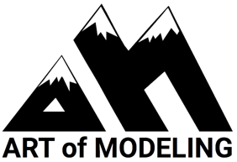
Fine art models provide a valuable service to the arts community. In order to ensure a professional environment for models, faculty/students, facilitators/artists, we ask that the following model standards and practices be followed:

Artist-Student Conduct:

- Silence cell phones & put them away while the model is unrobed to ensure no unauthorized photographs or videos

- Never photograph a model, without first asking and being granted model permission via the instructor/model coordinator. Models always have the right to decline a nude photograph (although, the many of them are used to and totally okay with it!)

- Once a break ends & the pose commences, please refrain from talking as the model is concentrating/musing

- As an artist, if you arrive late or leave early, please attempt to coordinate your entrance/exit timing with breaks as to not disturb the model and other artist’s focus

- Never go into/onto the model’s private, designated areas (dais/changing/break area)

- You can certainly be friendly, but do not overly converse with the model or ask the model personal questions. Any relevant on-site questions or requests should be made via the moderator (or instructor). Do not comment on a model’s body.

- If an individual artist present would like to book any AOM model, either at the same venue or at a different venue, they are to do so through AOM only

- Do not ask a model for their personal contact information, or offer yours to the model. AOM serves the role as the sole liaison for all matters

Student Printed Name: ____________________________________________________

Student Signature: ________________________________________________________
*By signing, you are agreeing to adhere to the code of conduct stated in this document

Parent Signature: ________________________________________________________
*By signing you are giving permission for your minor to draw from a nude art model

